Ocean Patriot - Stop Card of the Week
22 Janurary 06

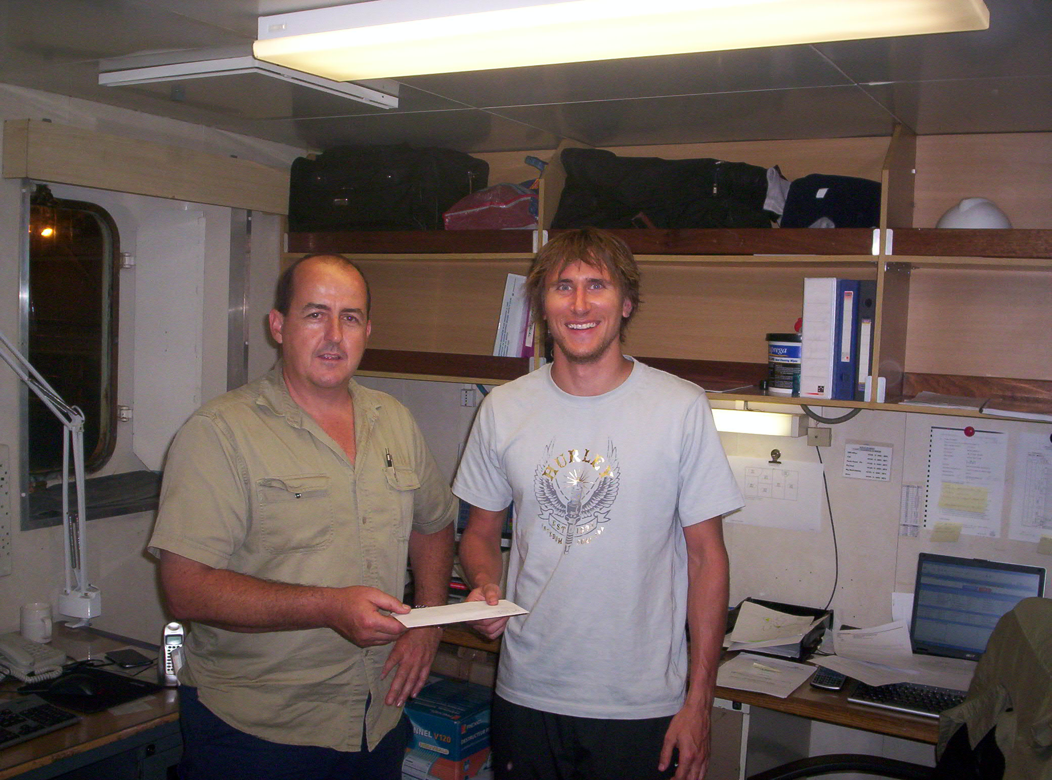
Sham Sawicki “stop card “award winner for week ending 22nd January 2006. Sham observed hair lined cracks around the base of the “V” door stanchion post, repairs were made and the equipment was returned to premium condition before riser pulling operations where the post is used extensively. This was found during his normal work scope and emphasis’s the crews continued interest in safety in there work place. “Nobody gets Hurt”!

